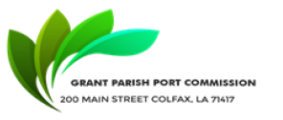

NOTICE OF PUBLIC MEETING
GRANT PARISH PORT COMMISSION
Notice Posted: December 10, 2025, at 9:00 AM
A public meeting will be held as follows:
DATE: December 11, 2025, at 9:00 AM
PLACE OF MEETING:
Grant Parish Police Jury.

AGENDA
- CALL MEETING TO ORDER
- ROLL CALL
- MOTION TO ACCEPT THE March Minutes
- OLD BUSINESS
- NEW BUSINESS
- MOTION TO ADJOURN

Charlene Anderson, Secretary
Grant Parish Port Commission
200 Main Street, Colfax, LA 71417

In accordance with the Americans with Disabilities Act, if you need special assistance, please contact Charlene Anderson at (318) 627-3157, describing the assistance that is necessary.

